Manual vs automated Flexsim project

Project Title: Manual vs Automated FlexSim Simulation
Name: Usman Bashir
University: UET Taxila
Semester: 7th Semester, Industrial & Manufacturing Engineering
Date: December 2025

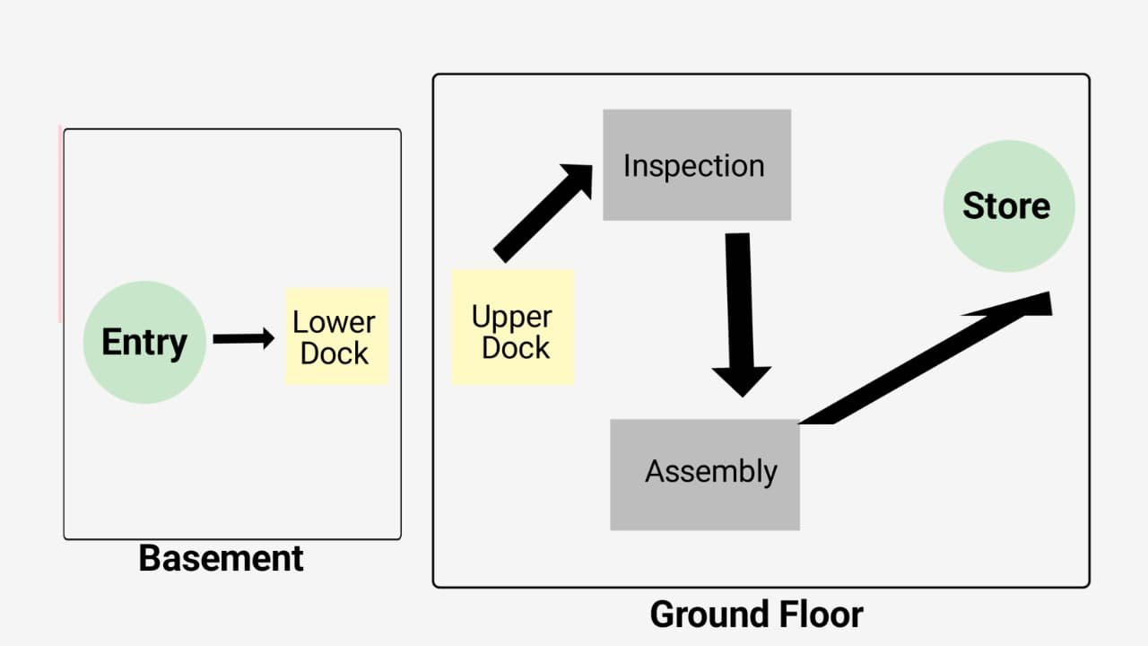
Figure 1: Layout

1. Introduction
FlexSim Software is a powerful 3D simulation tool used for modeling, analyzing, and optimizing manufacturing and logistics systems. It allows engineers to create virtual models of real-world processes, test different scenarios, and evaluate system performance without disrupting actual operations. By simulating workflows, resource allocation, and automation strategies, FlexSim helps identify bottlenecks, improve efficiency, and support decision-making in Industry 4.0 environments.
Purpose of Simulation: The purpose of this project is to evaluate and compare the performance of a manual material handling system with an automated system. The manual system relies on operators to move products through different stations, while the automated system uses elevators, automated guided vehicles (AGVs), and a dispatcher to handle material flow.
Objective:
- To measure the difference in throughput, utilization, and efficiency between manual and automated systems.
- To highlight how automation improves productivity and reduces idle time compared to manual operation.
- To provide a clear analysis of key performance indicators (KPIs) such as throughput, cycle time, utilization, and work-in-process (WIP).
2. System Flow
2.1 Manual Flow
- Source → Basement Dock → Upper Dock → Inspection → Assembly → Store
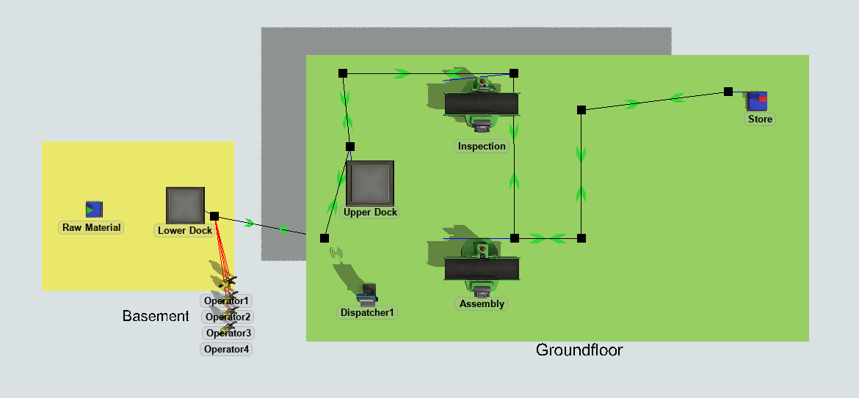
- All processes handled by operators.
Figure 2: Manual flow layout

2.2 Automated Flow
- Source → Basement Dock → Elevator → Upper Dock → AGVs → Inspection → Assembly → Store
- Processes handled by automated system (Elevator + AGVs + Dispatcher).
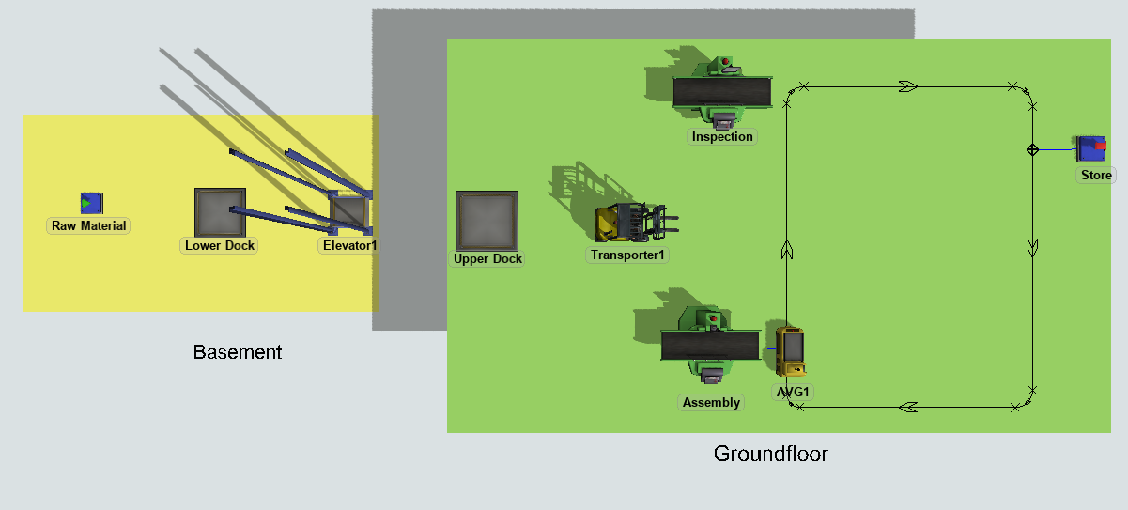
Figure 3: Automated flow layout

3. Results
3.1 Manual Results
- With 1 operator → Output = 30
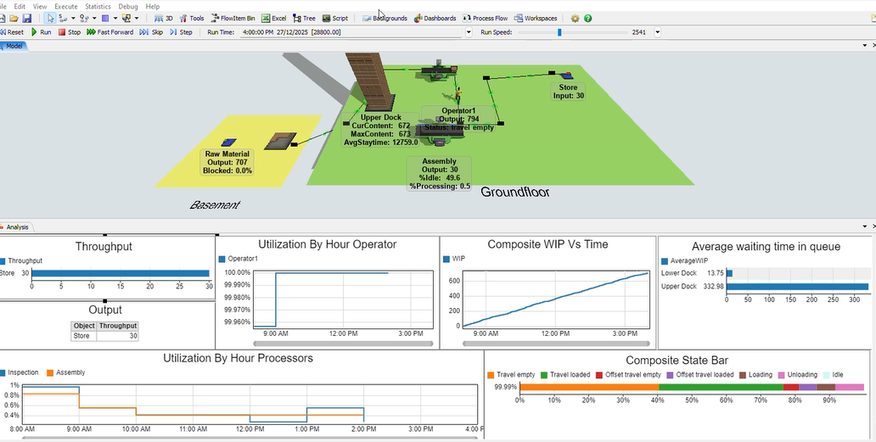
Figure 4: Result with 1 Operator

- With 4 operators + dispatcher → Output = 480
- Arrival time = 40 sec per product
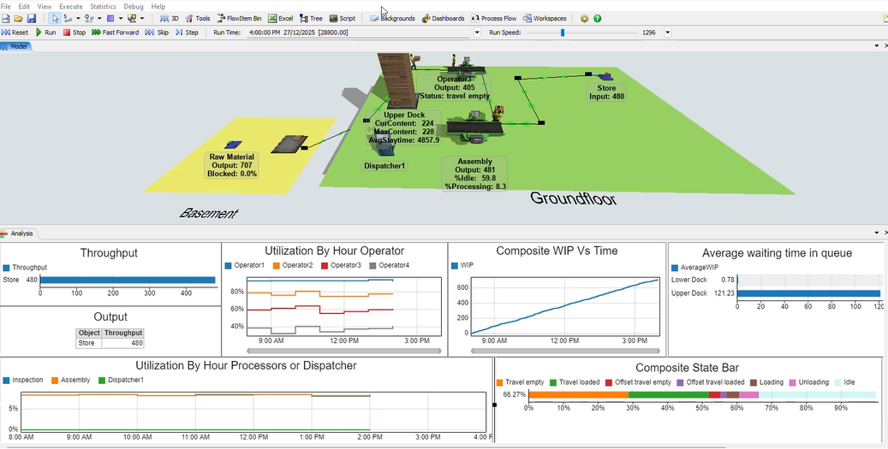
Figure 5: Result with 4 Operators
3.2 Automated Results
- Automated system output = 604
- Arrival time = 40 sec per product
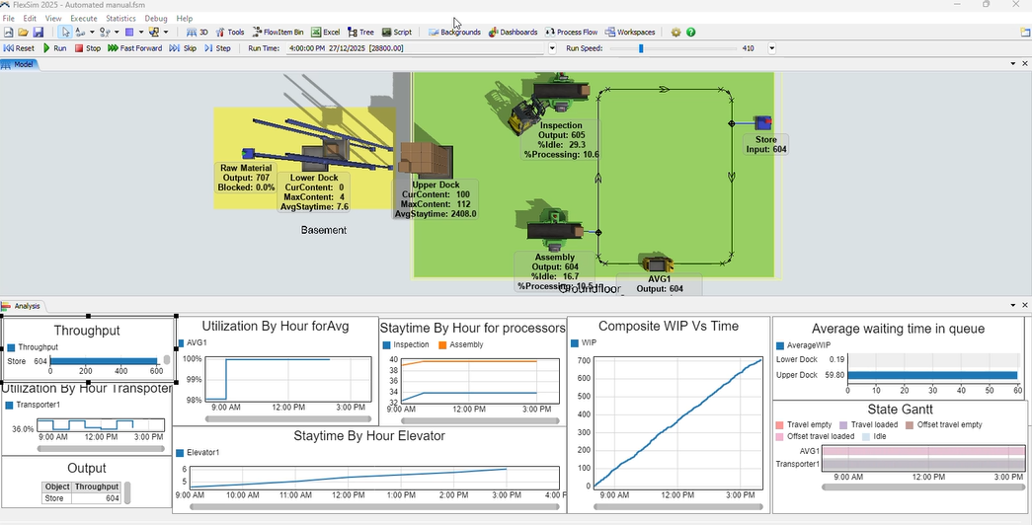
Figure 6:Automated system

4. Summary of KPI Results
All key performance indicators (KPIs) including Elevator Cycle Time, AGV Utilization, Queue Waiting Time, Throughput Trend, AGV Travel Distance, Task Assignment Count, Station Processing Time, and WIP Trend have been presented through the respective screenshots and charts.
The results clearly demonstrate system performance and highlight the differences between manual and automated operations.
5. Discussion
The comparison between manual and automated systems clearly shows the advantages of automation in material handling.
- Manual System: With only one operator, the throughput was limited to 30 items. Even when four operators and a dispatcher were used, the output increased to 480 items, but operator fatigue and limited handling capacity created constraints. The process was highly dependent on human efficiency, which introduced variability and idle times.
- Automated System: By integrating an elevator, AGVs, and a dispatcher, the automated system achieved a throughput of 604 items under the same arrival rate. Automation ensured consistent handling speed, reduced idle time, and balanced workload distribution among AGVs.
- Bottlenecks Observed: One key bottleneck was Upper Dock congestion, where items accumulated due to limited transfer capacity. This caused delays in flow and highlighted the need for better task assignment rules or additional AGVs.
- Improvement Through Automation: Automation reduced idle time at stations, improved cycle consistency, and minimized waiting times. AGV utilization charts showed balanced workload, while throughput trends confirmed higher productivity compared to manual operation.
Overall, the automated system demonstrated superior efficiency, reliability, and scalability, making it a more effective solution for modern manufacturing and logistics environments.
- Worker Safety:
- In the manual system, operators were directly involved in material handling, which increased the risk of accidents, fatigue, and repetitive strain injuries.
- Automation (Elevator + AGVs) reduced direct human involvement in heavy lifting and repetitive transport tasks, thereby improving worker safety.
- AGVs follow predefined paths and safety rules, minimizing collisions and unsafe handling compared to manual labor.
- Work Environment:
- Manual handling required more physical effort, leading to higher stress and potential ergonomic issues for workers.
- Automated systems created a cleaner and more organized environment, as material flow was controlled and predictable.
- Reduced congestion at stations and smoother flow improved overall workplace efficiency and reduced noise and chaos.
6. Conclusion
- Manual system limited by operator capacity.
- Automated system improved throughput (604 vs 480).
- AGVs + Elevator + Dispatcher = efficient material handling.

